STUDENT MANAGEMENT SYSTEM



Documented By:-
Piyush Kumar
Musthakhdhim P
Shiny Zebalda
Shashi Kant
Jadi Sidharth
Pragati Chaubey

Content

1.Introduction.
2.Objective.
3.Scope.
4.Significations.
5.Modules.
- Login Module.
- Students Module.
- Fees Module.
- Attendance Module
- Marks Module
6.User Interface Design.
7.Technologies Used.
- Front End.
- HTML.
- CSS.
- JavaScript.
- Back End.
- Java.
- Spring Boot.
- Spring Data JPA.
- Spring Security.
- Database.
- Oracle SQL
8.Hard Ware Requirements.
9.Project Life Cycle.
10.Snapshots.
11.Dataflow Diagram.
12. Use Case Diagram.

Introduction

Today, the world is getting digitalized for getting more productivity and innovative. So there must be a digital system to keep the records of student. A Student Management System is designed to keep records of student regarding admission, fees, courses and attendance etc.

To better perform the administrative activities of educational institute Student Management System ensures the better performance. Such application can make the system easier to navigate and to use max in mini time. SMS allows the keeping of personal data in a form that can be easily accessed.

2.Objective
- To develop an online system to help the users.
- To manage the details of students.
- To track the records and to modify.

3.Scope
Our project aims to safe and easy handling of students. i.e. we have made a computerized process to store data and management.

- It satisfies the admin.
- It is easy and safe to store data.
- It is easy to operator.
- Have a good user interface.
- It saves time and function faster.
- It helps the admin to handle the records of students.

We have tried to develop safe and secure software with above mentioned specifications.

4.Significations
- Easy to update information.
- Work becomes speedy.
- Access of student information individually.
- Decrease the load of the person involve in existing manual system.
- Well-designed reports.
- Easy & fast retrieval of information.
- Accuracy in work.
- It contains better storage capacity.
- Robust database back-end.
- Creating and changing data at ease.

5.Modules

Login-Registration module :-
Only admin can log in to the system as the end-user of the system on the behalf of the user. The user will get only username and password once the user get register.

After successful login user will enter to the homepage of SMS Where he/she can manage the details of students.
Students Module :-
In this module, the user can manage the fee details of students and can access it easily any time.
Fee Module :-
In this module, the user can manage the fee details of students and can access it easily any time.
Attendance Module :-
In this module, the user can manage the attendance details of students and can access it easily any time.
Marksheet Module:-
In this module, the user can manage the details of marks of students and can access it easily any time.

6.User Interface Design
User Interface Design is concerned with the dialogue between a user and the computer. It is concerned with everything from starting the system or logging into the system to the eventually presentation of desired inputs and outputs. The overall flow of screens and messages is called a dialogue.
The following steps are various guidelines for User Interface Design:
• The system user should always be aware of what to do next.
• The screen should be formatted so that various types of information, instructions and messages always appear in the same general display area.
• Use display attributes sparingly.
• Default values for fields and answers to be entered by the user should be specified.
• A user should not be allowed to proceed without correcting an error.
• The system user should never get an operating system message or fatal error.

7.Technologies Used
Front End:
1.Angular

HTML:
HTML (Hypertext Markup Language) is the code that is used to structure a web page and its content. For example, content could be structured within a set of paragraphs, a list of bulleted points, or using images and data tables.
CSS:
Stands for "Cascading Style Sheet." Cascading style sheets are used to format the layout of Web pages. They can be used to define text styles, table sizes, and other aspects of Web pages that previously could only be defined in a page's HTML.
JavaScript:
JavaScript (JS) is a scripting language, primarily used on the Web. It is used to enhance HTML pages and is commonly found embedded in HTML code. JavaScript is an interpreted language. Thus, it doesn't need to be compiled. JavaScript renders web pages in an interactive and dynamic fashion. This allowing the pages to react to events, exhibit special effects, accept variable text, validate data, create cookies, detect a user’s browser, etc.

Back End:
Java:
Java is a general-purpose, class-based, object-oriented programming language designed for having lesser implementation dependencies. It is a computing platform for application development. Java is fast, secure, and reliable, therefore. It is widely used for developing Java applications in laptops, data centers, game consoles, scientific supercomputers, cell phones, etc.
Spring Boot:
Spring Boot is an open-source micro framework maintained by a company called Pivotal. It provides Java developers with a platform to get started with an auto configurable production-grade Spring application. With it, developers can get started quickly without losing time on preparing and configuring their Spring application.
Spring Data JPA:
JPA is a Java specification that is used to access, manage, and persist data between Java object and relational database. It is a standard approach for ORM.
Database:
Oracle SQL:
SQL (pronounced sequel) is the set-based, high-level declarative computer language with which all programs and users access data in an Oracle database. Although some Oracle tools and applications mask SQL use, all database tasks are performed using SQL.

8.Hard Ware Requirements:

 | Minimum System Requirement. | Recommended System Requirement.
Processor | 7th Gen Intel Core i7 | 9th Gen Intel Core i7 or better
RAM | 4GB | 8GB or more
Storage | 256GB SSD | 512GB or more
Display | 14-inch FHD (1920 X 1080) | 15.6-inch FHD IPS(1920 X 1080)
Graphics | 4GB NVIDIA GeForce GTX 1060 | 8GB NVIDIA GeForce GTX 2070
Battery | Up to 2 hours | Up to 5 hours

9.Project Life Cycle:
Agile Software Development Methodology:
The Agile software development methodology is one among the only and effective processes to show a vision for a business need into software solutions. Agile may be a term want to describe software development approaches that employ continual planning, learning, improvement, team collaboration, evolutionary development, and early delivery. It encourages flexible responses to vary.
The agile software development emphasizes on four core values.
- Individual and team interactions over processes and tools
- Working software over comprehensive documentation
- Customer collaboration over contract negotiation
- Responding to change over following a plan

Phases of Agile Methodology:
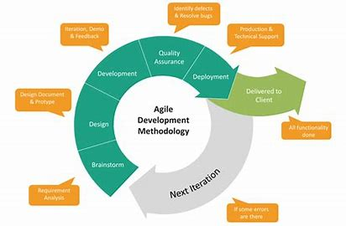
Agile Methodology Phases
Phase-1: Requirement Analysis: - In this phase, we gather data and analyses how Student Management System works. Also collected requirements after reviewing earlier papers & websites.
Phase-2: Design: - On the basis of gathered information we designed and build a model.
Phase-3: Development: - Deliver the working software based on iteration, requirements or feedback.
Phase-4: Quality Assurance: - This is a testing phase where we test our model.
Phase-5: Deployment: - In this phase we deploy our final release of the iteration into production.
Phase-6: Feedback: - Accept the user feedback and work it into the requirements.

10.Snapshots

Login page:

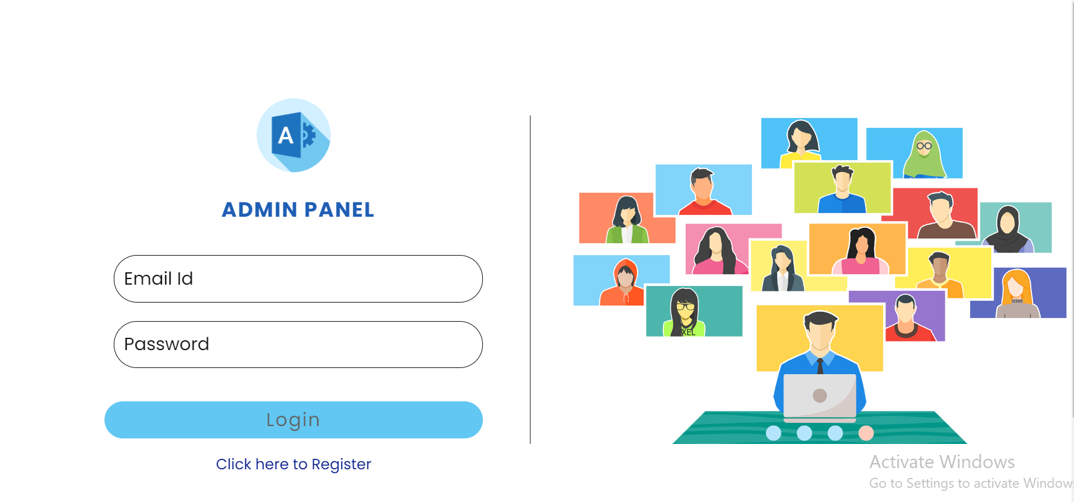
Registration page:
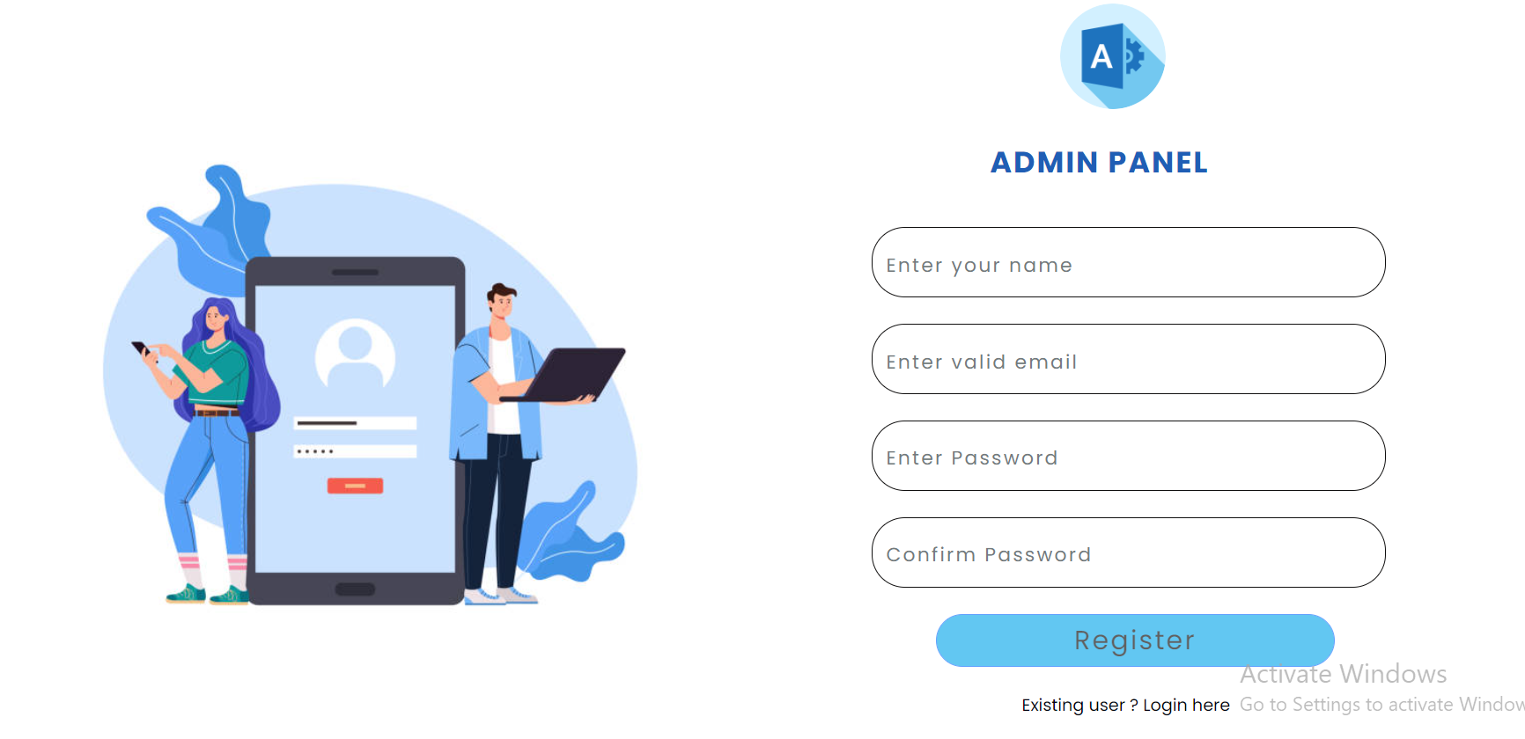
Home Page:

Student Info:
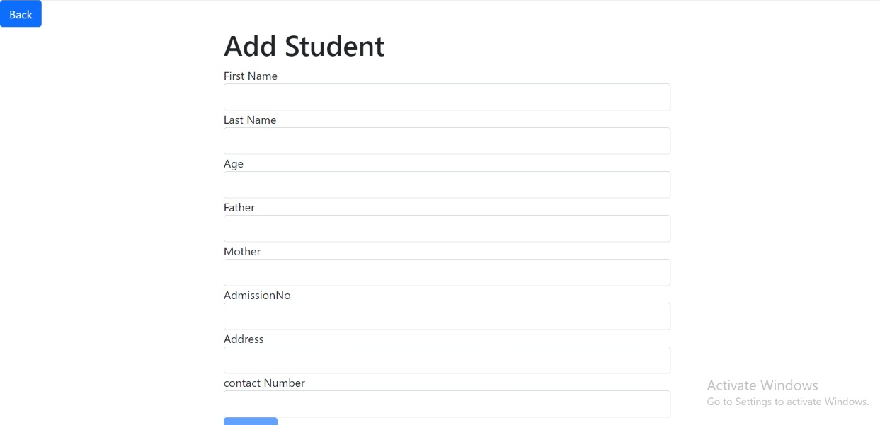
Add students:

Brief Description | Add Student.
Basic Flow | This use case describes how an admin can add new students to system.  - Admin have to login.  - Select add student bar.  - Enter details and add new student.  - The following information is required during adding the member.  - First Name  - Last Name  - Age  - Father’s Name  - Mother’s Name  - Admission No.  - Address
Alternate Flow | - The system will validate the information provided. If any invalid data is found, the input form will be redirected with error message.
Validation | 1.First Name, Last Name, Age, Father’s Name, Mother’s Name, Admission No, Address are required.  2.Provided details should valid.
Pre-Conditions | Admin should have network access and Browser with latest updates.
Post-Conditions | Success popup should be shown after clicking submit button.

Fee Info:
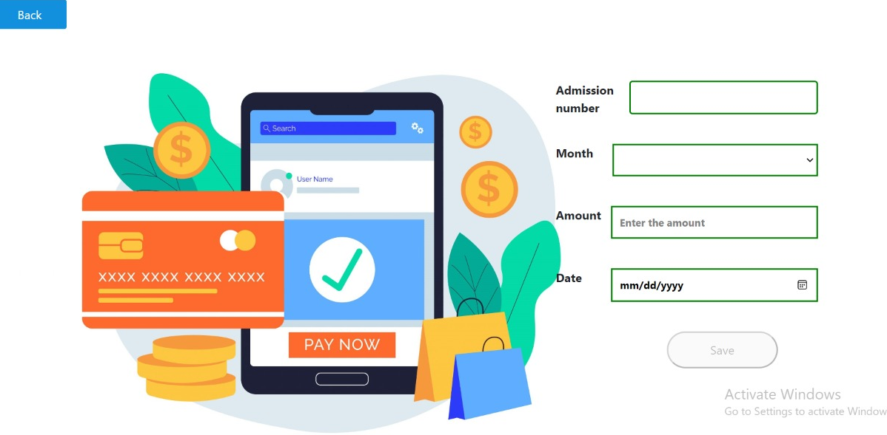
Add fee:

Brief Description | Add Fees
Basic Flow | This use case describes how an admin can add new students to system.  - Admin have to login.  - Select add fee bar.  - Enter details and add fee details.  - The following information is required during adding the member.  - Admission number  - Month  - Amount  - Date
Alternate Flow | - The system will validate the information provided. If any invalid data is found, the input form will be redirected with error message.
Validation | 1.Admission number, Month, Amount, Date are required.  2.Provided details should valid.
Pre-Conditions | Admin should have network access and Browser with latest updates.
Post-Conditions | Success popup should be shown after clicking save button.

Attendance Info:
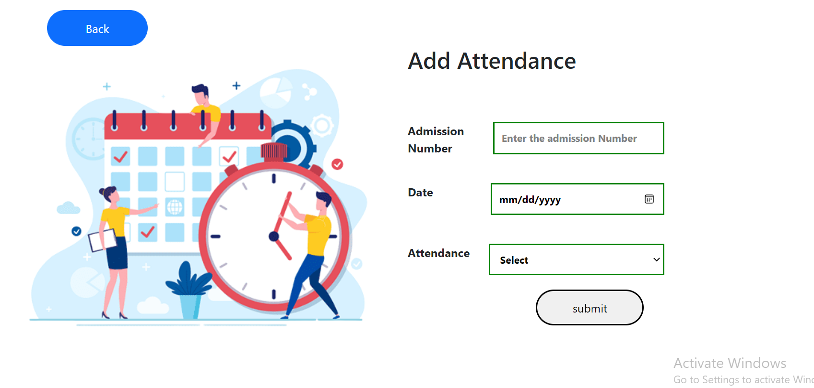
Add Attendance:

Brief Description | Add Attendance
Basic Flow | This use case describes how an admin can add new students to system.  - Admin have to login.  - Select add attendance bar.  - Enter details and add attendance details.  - The following information is required during adding the member.  - Admission number  - Date  - Attendance
Alternate Flow | - The system will validate the information provided. If any invalid data is found, the input form will be redirected with error message.
Validation | 1.Admission number, Date, Attendance are required.  2.Provided details should valid.
Pre-Conditions | Admin should have network access and Browser with latest updates.
Post-Conditions | Success popup should be shown after clicking save button.

Marks Info:
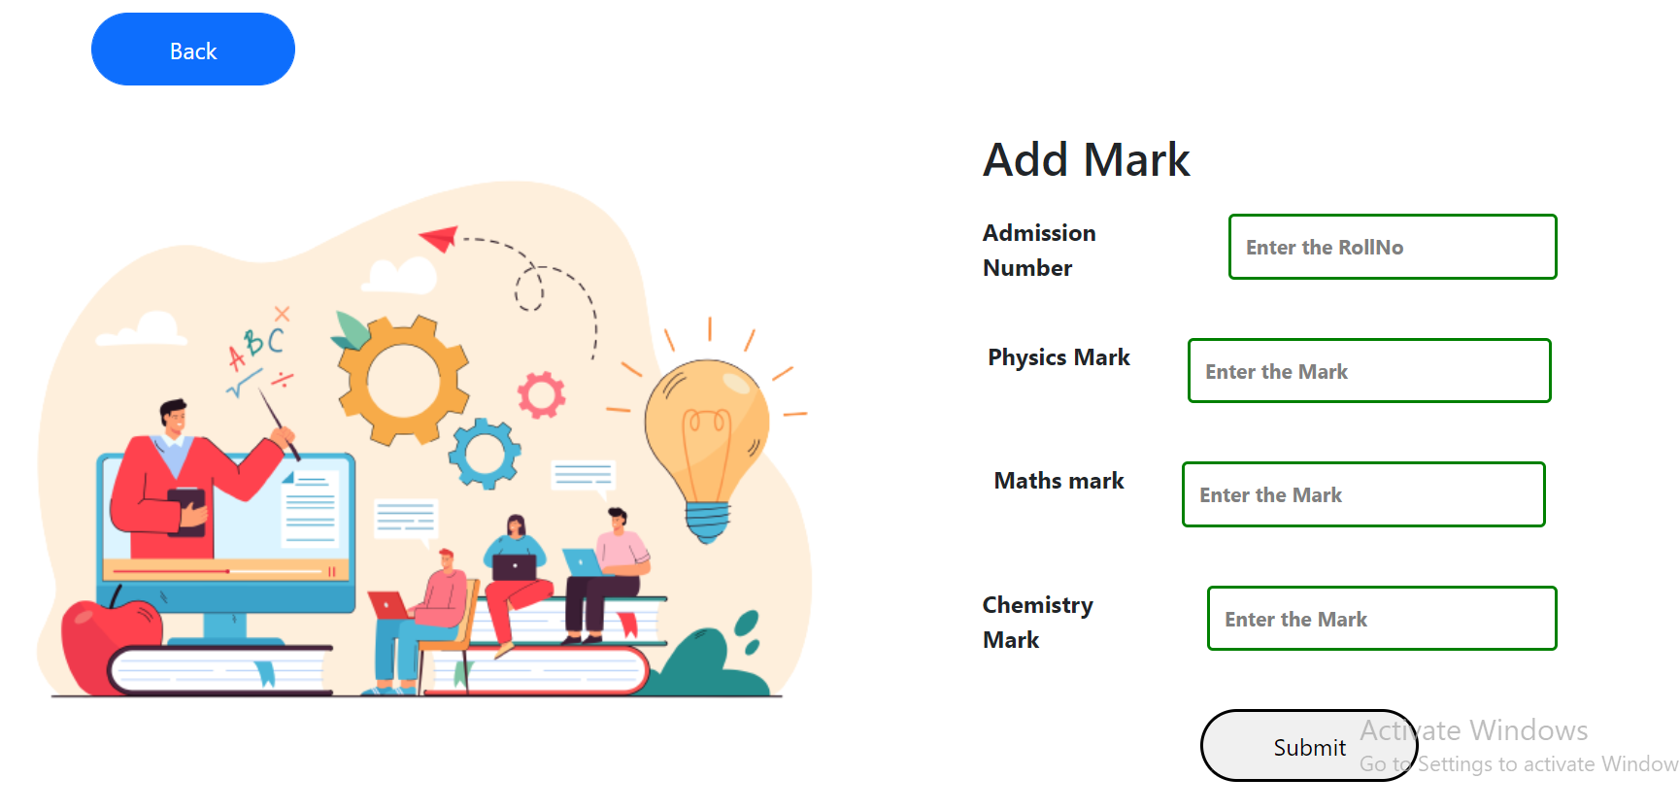
Add Marks:

Brief Description | Add Marks
Basic Flow | This use case describes how an admin can add new students to system.  - Admin have to login.  - Select add attendance bar.  - Enter details and add attendance details.  - The following information is required during adding the member.  - Admission number  - Physics Marks  - Math’s Marks  - Chemistry Marks
Alternate Flow | - The system will validate the information provided. If any invalid data is found, the input form will be redirected with error message.
Validation | 1.Admission number, Physics marks, Math’s marks, Chemistry Marks required.  2.Provided details should valid.
Pre-Conditions | Admin should have network access and Browser with latest updates.
Post-Conditions | Success popup should be shown after clicking save button.

11.Data Flow Diagram:
A data flow diagram should be the first mechanism used by framework analyst to model system fundamental. These fundamentals are the system operations; the information used by this operations and external organization that interact with the framework and the data flows in the system.

Admin

Home Page
Add Student
Add Attendance

Add Fees
Marks Info.

Student Info.
Fees Info.
Marks Info.
Attendance Info
Search

Class
Roll no.
Reg. Number
Student Name

11.Use Case Diagram:
A use case depicts a series of steps that give something significant value to an actor and is drawn as a horizontal ellipse. A use case diagram apprehends the functional features of a system with processes implement in the system. While discussing the functionality and procedures of the framework, you discover important characteristics of the framework that you represent in the use case diagram

LOGIN
Add Attendance
Add Fee
Add Students
Add marks
Students Info
Fee Info.
Attendance Info
Marks Info
Search

Roll
Students
Registration
Class

